Bidding project ideas:

**Starting with creating the ability to create lots**   
1) Create basic object classes with the fields they require to match the tables planned for the database, for a User and a Lot. If desired, could also add a String name to the user, and some address details. Although not functionally required, it could make the program seem more friendly.

|  |  |  |  |
| --- | --- | --- | --- |
| **Table: Lot** | | | |
| **Column** | **Datatype** | **Attribute** | **Default** |
| lot_id | INT(11) | PK, AI |  |
| lot_noOfBids | INT(11) | NN |  |
| lot_bid_id | INT(11) | FK referencing Bid pk |  |
| lot_expirTime | DATE | NN |  |
| lot_user_soldTo | INT(11) | FK referencing User pk |  |
| lot_strtPrice | DECIMAL(15,2) | NN |  |
| lot_increment | DECIMAL(15,2) | NN |  |
| lot_trgtPrice | DECIMAL(15,2) |  |  |
| lot_description | VARCHAR(255) |  |  |
| **~~bid_expctdAmount~~** | DECIMAL(15,2) |  | NULL |

|  |  |  |  |
| --- | --- | --- | --- |
| **Table: User** | | | |
| **Column** | **Datatype** | **Attribute** | **Default** |
| user_id | INT(11) | PK, AI |  |
|  |  |  |  |
|  |  |  |  |

Next you need at add methods that provide you the ability to create users, and create lots for users.   
  
These methods can then be called from either the command line (main class), or from a test class (or a GUI)

Every method related to placing bids/creating lots will need a User id passed as part of the method.   
I see two options in this.   
  
Create a static class with all these methods, where the UserId is passed in each of these methods.

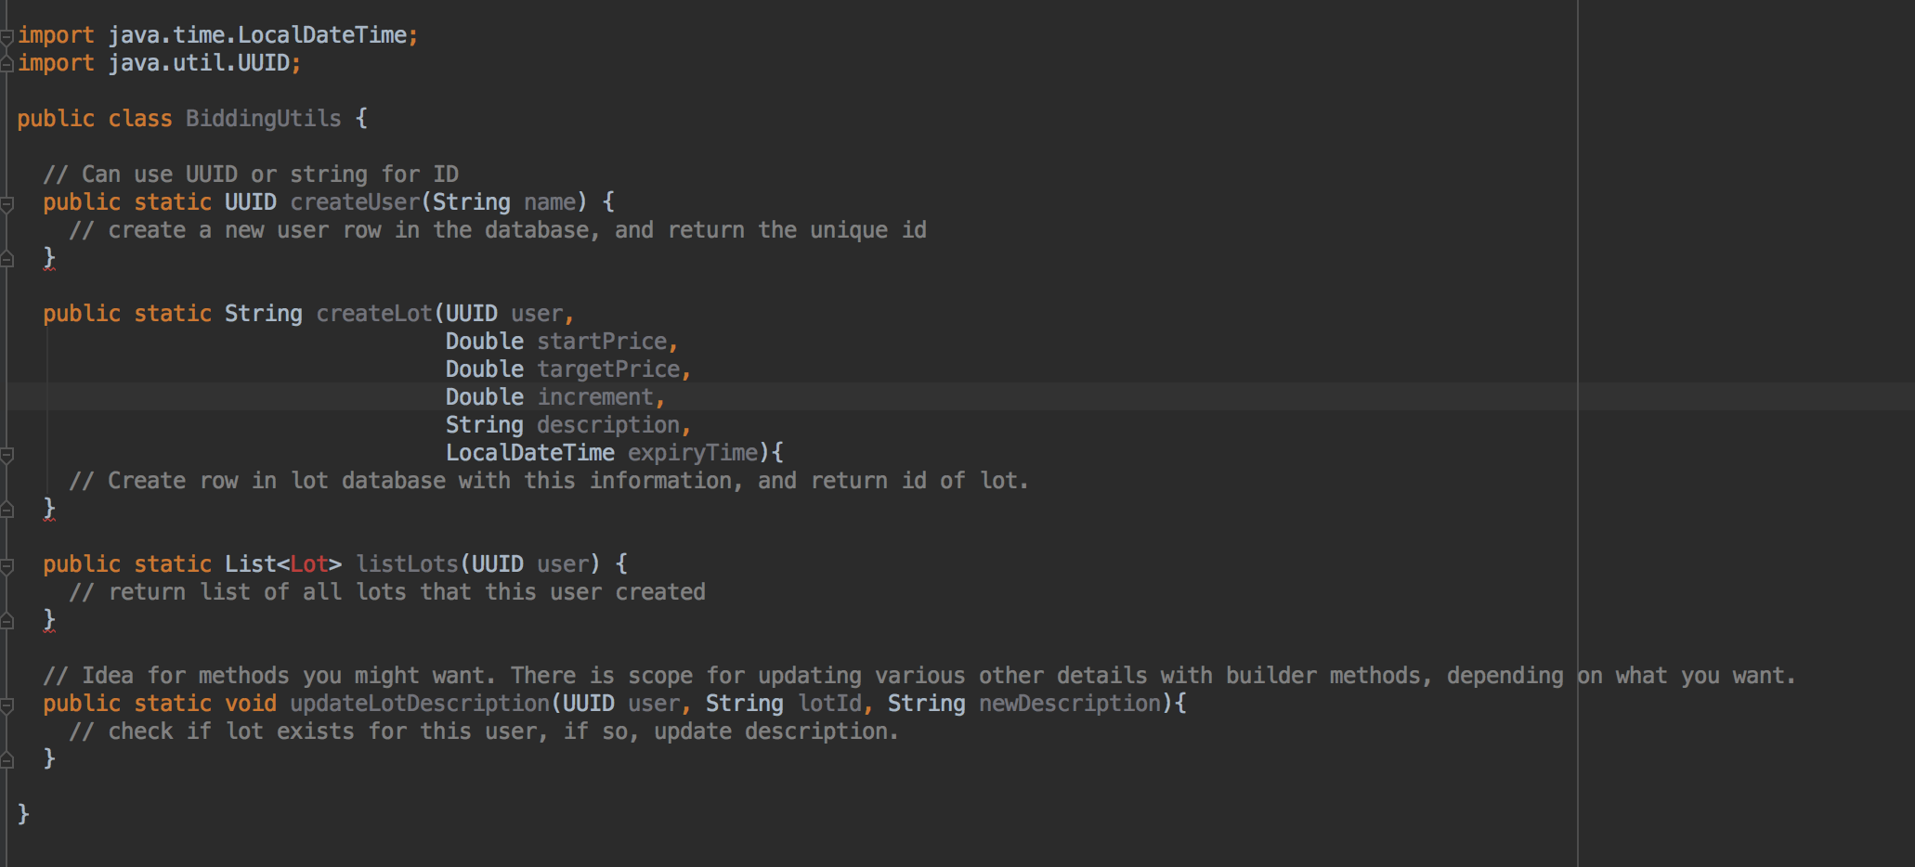

The other option is to create a class that gets initialized once by the user with their ID, so that all future methods until the command line closes use this class which holds the user ID

